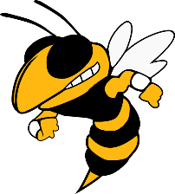

**2021 YULEE HORNETS FLAG FOOTBALL SCHEDULE (TENTATIVE)**

**ALL GAMES VARSITY ONLY**

**DATE TEAM TIME**

March 2nd **Atlantic Coast** 6:00

March 11th Baker County 4:30

March 15th Wolfson 6:00

March 18th First Coast 6:00

March 30th Hilliard 6:30

April 1st **Baker County**6:00

April 8th West Nassau (Game @FBHS) 5:30

April 15th  **FERNANDINA BEACH** 6:30

Home Games in Bold

Head Coach: D.J. Ford Athletic Director: Candace Hicken